PU Leather Midsize Colorful Golf Putter Grip
Material: synthetic/pu leather
Size:midsize golf putter grip
TPE core with synthetic leather wrap
Core:0.58/0.6
Weight:110+-3grams
Lenght:265+-3mm
Welcome OEM design
Timely delivery with competitive factory prices.
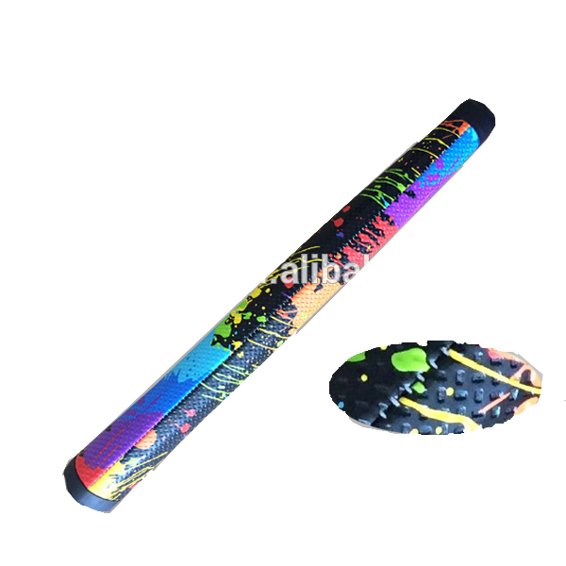
More information please click: www.tt-golf.com

